Adding OCL Licenses in Pressbooks

A copyright notice is required for all books in Pressbooks, as such, Pressbooks automatically generates an “All Rights Reserved” copyright license. You can change this default license type and apply a license of your choice on the Book Info page.
You can now select the Ontario Commons License (OCL)and Ontario Commons License - No Derivatives (OCL-ND) as license options in the eCampusOntario Pressbooks instance. The Ontario Commons licenses are reserved for the Virtual Learning Strategy projects.

Select Your License
To select your license, click the Book Info in your book dashboard. Then, on the Book Info page, scroll down to find the Copyright section. Select your license and click Save.
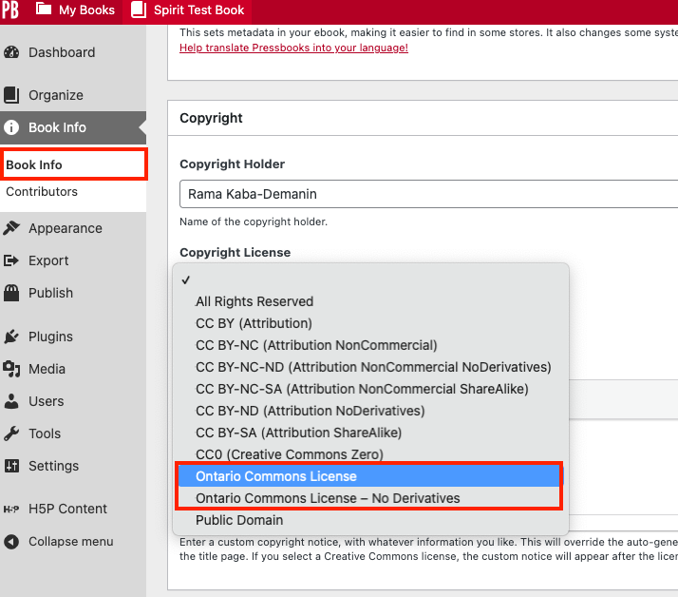

Private Book Visibility
To set your book visibility to private, click Settings, then Sharing & Privacy in your book dashboard. Select the “Private. I would like this book to be accessible only to people I invite.” option and then click Save Changes.
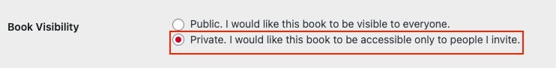
Private books by default are excluded from the Pressbooks Directory.

H5P Activity
Since the Ontario Commons licenses are not license options in the H5P Plugin, you must use the License Extras field to provide your licensing information. This is the only way your license choice will travel with your H5P activity outside of Pressbooks.
- To add your sharing and licensing information, select the Metadata button beside the Title field on the H5P Editor page. A pop-up window will appear, allowing you to choose a license and fill in the fields.

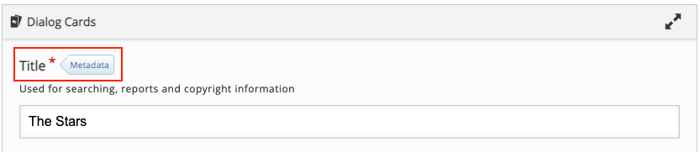

- Select either “Copyright” as your License or leave it as “undisclosed.”
- Use the Source field to enter the following URL: https://www.ecampusontario.ca/licensing/.
- Enter your license information in the License Extras field. You may use the following statements:

Example 1: This work is licensed under an Ontario Commons License.

Example 2: This work is licensed under an Ontario Commons License – No Derivatives.

- Click Save metadata to save your entry.
Sample H5P Content metadata element completed:
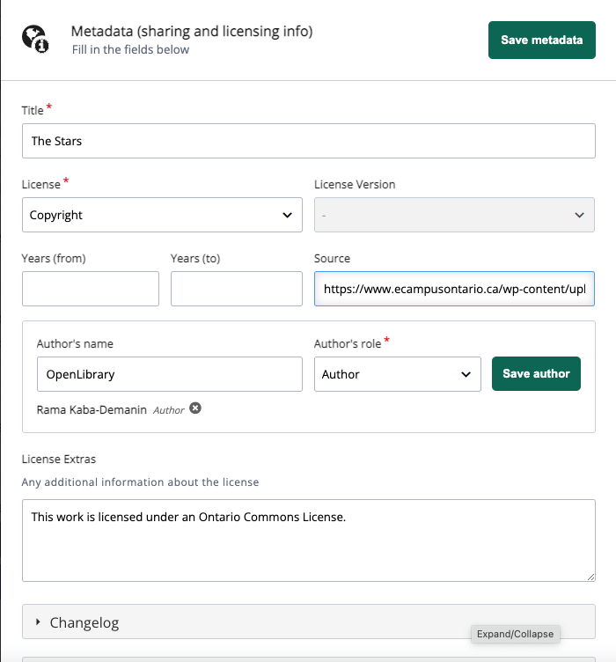

Considerations for selecting OCL in Pressbooks
- Your webbook will be private and will only be visible for logged-in users through the eCampusOntario catalogue.
- Users will be added as “subscribers” to your book in Pressbooks with read-only permission.
- The book clone feature is not available for Ontario Commons Licensed webbook. Users can use the Import tool to bring content into Pressbooks.
- H5P activities are not included in exported files. For Ontario Commons licensed resources with multiple H5P activities, a user may email us to clone the webbook for them.

Need more help? Contact Us

