Adding Licenses in eCO H5P Studio
By default, the H5P content license is listed as "undisclosed." "Undisclosed" means that a license type (i.e., a Creative Commons license, Public Domain, All Rights Reserved, etc.) has not been applied to the specific H5P ID. Content creators may choose not to select a license for various reasons, one of which may be that the author of the H5P ID is not the copyright holder but is reusing the material under a license that permits the sharing, distribution, adaptation, etc., of the content. Therefore, it is recommended that you contact the author(s) before reusing a content with an "undisclosed" license that does not display the "Rights of use" at the bottom of the content.
- To add your sharing and licensing information, select the Metadata button beside the Title field on the H5P Editor page. A pop-up window will appear, allowing you to choose a license and fill in the fields. 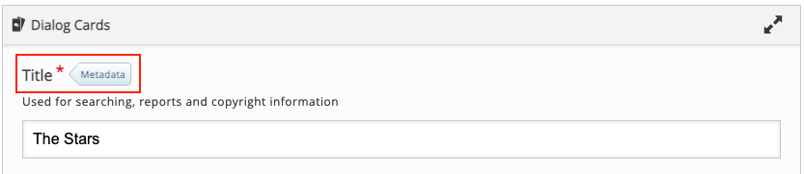

- By default, the license is listed as "undisclosed." Please change this option to a license of your choice. Fill in the fields making sure to provide all relevant information such as license version, contributors, license source, etc.
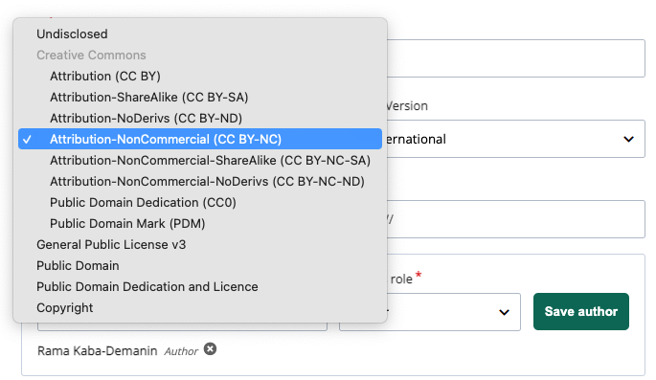
- Click Save metadata at the top of the window to save your entry.

Adding Ontario Common License
You can now select the Ontario Commons License (OCL)and Ontario Commons License - No Derivatives (OCL-ND) as license options in the eCampusOntario H5P Studio. The Ontario Commons licenses are reserved for the Virtual Learning Strategy projects.
You can find the License options between the Description and Options boxes. The default selection is “None.”
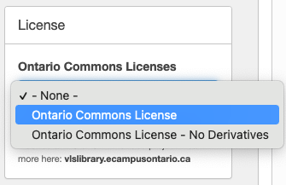
Your Ontario Commons license details will be displayed on your H5P Content page.
Please note that the Ontario Commons licenses will not export with your H5P Content as it is not part of the license options in the H5P Plugin. However, to ensure that your license information is transferred with your H5P activity outside of the eCampusOntario H5P Studio, please include your OCL or OCL-ND statement in the License Extras field. Follow the instructions above to add sharing and licensing information in the Metadata interface, but:
- Select “Copyright” as your License or leave it as “undisclosed.”

- Use the Source field to enter the following URL: https://www.ecampusontario.ca/licensing/.

- Enter your license information in the License Extras field. You may use the following statements:
This work is licensed under an Ontario Commons License.
This work is licensed under an Ontario Commons License – No Derivatives.

- Click Save metadata to save your entry.
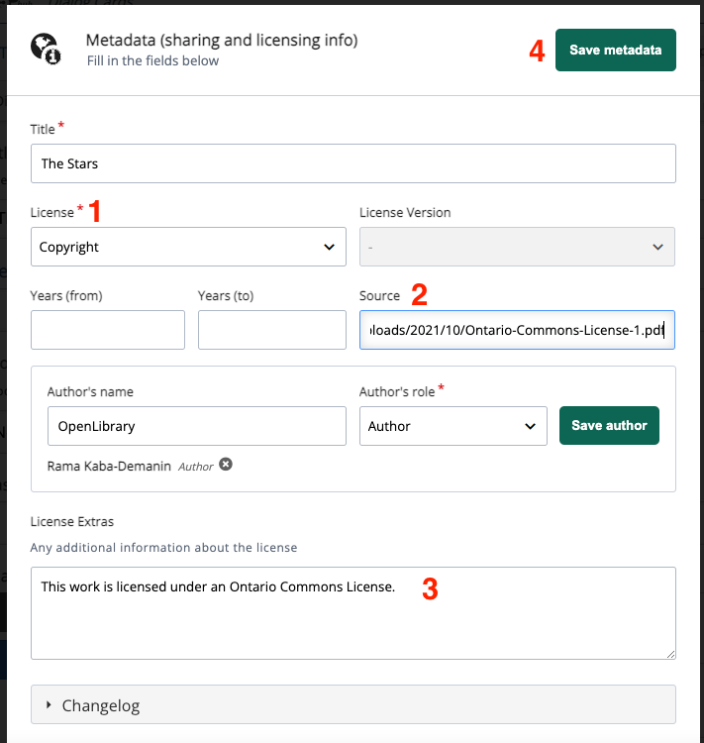
Need more help? Contact Us

